Ethernet Standard and Specification
Task – 1 : Draw a labeled diagram of a Cat6 Ethernet cable, showing the color order of wires in the T568B standard and labeling the RJ-45 connector pins.
Solution : RJ-45 Pin Layout and T568A / T568B
An RJ-45 Ethernet connector has 8 pins. The two commonly used wiring standards are T568A and T568B.
RJ-45 Pin Layout
When viewing the connector with the gold contacts facing you and the clip facing away/down, the pins are numbered from 1 to 8 from left to right.

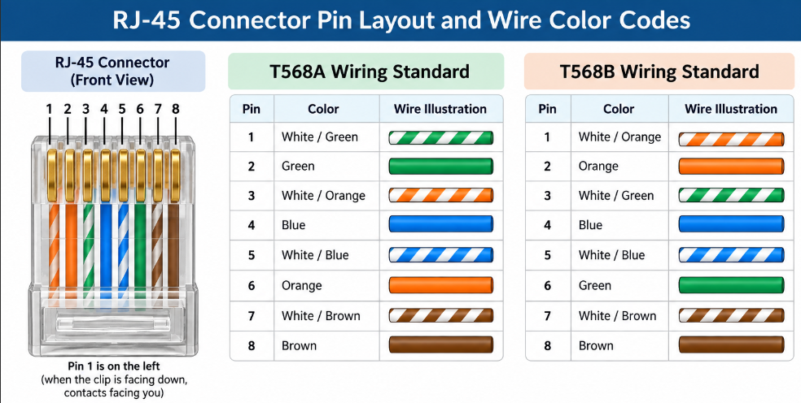

Task – 2 : Create a table comparing the key specifications of Ethernet standards 10BASE-T, 100BASE-TX, and 1000BASE-T, including speed, cable type, maximum cable length, and connector type.
Solution : Ethernet Standards Comparison
Ethernet Standard | Speed | Cable Type | Maximum Cable Length | Connector
10BASE-T | 10 Mbps | Cat3 or better twisted-pair | 100 m | RJ-45
100BASE-TX | 100 Mbps | Cat5 or better twisted-pair | 100 m | RJ-45
1000BASE-T | 1 Gbps | Cat5e or better twisted-pair | 100 m | RJ-45

Task – 3 : Given a scenario where you need to connect two laptops directly using Ethernet, explain which cable (straight-through or crossover) you would use and why. Hint : Think about how transmit and receive pairs are wired in each cable type.
Solution : Connecting Two Laptops Directly
If two laptops need to be connected directly to each other without a switch or router, traditionally a crossover Ethernet cable would be used.
In traditional Ethernet, the transmitting and receiving pairs of one device need to connect to the corresponding receiving and transmitting pairs of the other device.

- Straight-Through vs Crossover
Cable | Wiring | Traditional Use
Straight-through | Same standard at both ends, e.g. T568B → T568B | Laptop → Switch
Crossover | Different standards at each end, e.g. T568A → T568B | Laptop → Laptop

Important Modern Note
Most modern laptops and Ethernet devices support Auto-MDI/MDI-X, which automatically detects the transmit/receive configuration. Therefore, a modern laptop-to-laptop connection may work with a normal straight-through cable as well.

Task – 4 : List three real-world devices in your home or college that use Ethernet connections, and for each, specify the likely Ethernet standard (e.g., 100BASE-TX, 1000BASE-T) they support.
Solution : Three Real-World Devices Using Ethernet
1. Desktop Computer
A desktop computer can use Ethernet to connect to a network switch or router. A wired connection provides stable and reliable network communication.

Desktop PC ───── Ethernet Cable ───── Switch

2. Wi-Fi Router
A Wi-Fi router commonly has Ethernet ports that connect it to devices such as computers, switches, or an ISP's modem/ONT.

Internet/ONT ───── Router ───── Laptop
│
Ethernet

3. Network Printer
A network printer can use Ethernet to connect to the LAN. Multiple computers on the same network can then send print jobs to it.

Computer 1 ──┐
Computer 2 ──┼── Switch ─── Network Printer
Computer 3 ──┘

